<!--This file created 2:29 PM 10/29/97 by Claris Home Page version 2.0-->1.1 Project
A Square Wading Pool

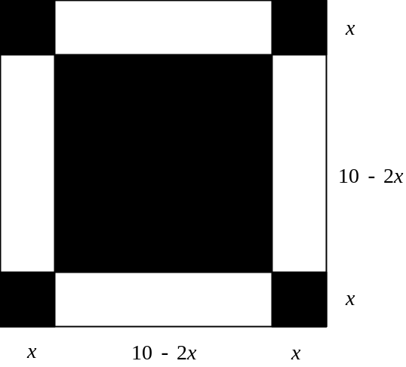

Suppose we make a wading pool by cutting a square of edge length x from each of the four corners of a 10-ft square piece of tin, and then turning up each of the 4 remaining flaps to form an open-topped square box that will hold water after you solder its four vertical edges. The resulting box will have height (or depth) x and will have a square base with edge length 10 – 2x. Therefore its volume V is given by

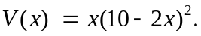 (1)

Most graphing calculators and computer algebra systems have convenient capabilities for the numerical tabulation of functions. Then the tabulations

x | V(x) |  | x | V(x)
0 | 0 |  | 1 | 64.00
0.5 | 40.5 |  | 1.1 | 66.92
1 | 64 |  | 1.2 | 69.31
1.5 | 73.5 |  | 1.3 | 71.19
2 | 72 |  | 1.4 | 72.58
2.5 | 62.5 |  | 1.5 | 73.50
3 | 48 |  | 1.6 | 73.98
3.5 | 31.5 |  | 1.7 | 74.05
4 | 16 |  | 1.8 | 73.73
4.5 | 4.5 |  | 1.9 | 73.04
5 | 0 |  | 2 | 72.00

suggest that we get the wading pool of maximum possible volume if the corner notch edge length x is approximately 1.7 feet — because this value of x corresponds to the largest value (approximately 74 cubic feet) of V that we see when we scan the second column in the right-hand table above. By "zooming in" near this value — perhaps by tabulating next on the interval from x = 1.65 to x = 1.75 — we could determine the maximum value as closely as we please.

Suppose, on the other hand, that you wanted to construct (from the same 10-ft square piece of tin) a wading pool with a volume of exactly 37 cubic feet. Can you see from the left-hand table above that there appear to be two values of x — one a bit less than 0.5 feet, and the other between 3 and 3.5 feet — that you could use for the edge length of the corner notch? By zooming as before, either could be determined more closely.

For you own personal wading pool, start with a square piece of tin whose edge measures a feet, where a denotes the largest digit in your student ID number. You want to determine the corner notch edge length x so that the wading pool you construct (as above) will have the largest possible volume V. Start by expressing the box's volume V = f(x) as a function of its height x, and then use the method of repeated tabulation to find the maximum value Vmax (rounded off accurate to 2 decimal places) attained by the function f(x) on the interval [0, a/2]. (Why is this the appropriate domain of f ?)

For a second investigation, suppose you decide instead that you want your pool to have exactly half the maximum possible volume Vmax . Note first that a tabulation of f(x) on the interval [0, a/2] indicates that this is true for two different values of x. Find each of them (rounded off accurate to 3 decimal places).

Write up the results of your investigations in the form of a carefully organized report consisting of complete sentences (plus pertinent equations and data tables) explaining your results in detail, and telling precisely what you did to solve your problems.

The sections below illustrate the use of graphing calculators and computer algebra systems to apply the method of magnification for the solution of pairs of equations like (2) and (3).

Using a Graphing Calculator
The following TI-83 calculator screens show the right-hand side function in (1) defined in the Y= menu, the TBLSET menu set up for a table of values starting at x = 0 and with step size 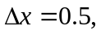 and the resulting tabulation.

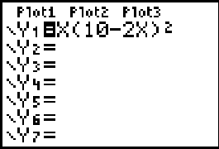
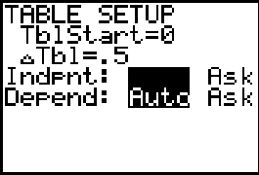
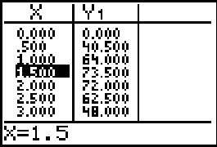

The next two tabulations, first with x₀ = 1 and 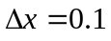 and then with x₀ = 1.65 and 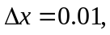 indicate that a corner notch edge length 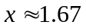 feet yields a wading pool with maximum volume 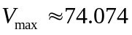 cubic feet.
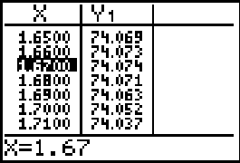
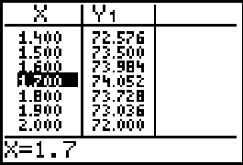

The next two tabulations, first with x₀ = 0.4 and 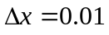 and then with x₀ = 0.44 and 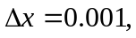 indicate that a corner notch edge length 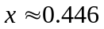 feet yields a wading pool with volume almost exactly 37 cubic feet.

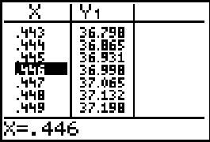
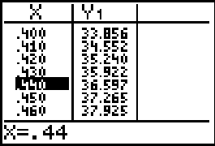

Finally the next two tabulations show that we also get a wading pool with volume almost exactly 37 cubic feet with corner-notch edge length 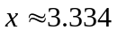 ft.
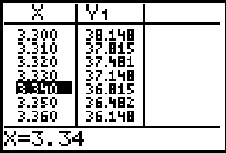
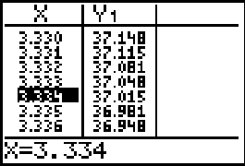

Using Maple

First let's define the volume function in (1) by

V := x -> x*(10-2*x)^2;

Then the tabulation

for x from 0 by 0.5 to 5 do print (x,f(x)) od;
0, 0
.5, 40.500
1.0, 64.000
1.5, 73.500
2.0, 72.000
2.5, 62.500
3.0, 48.000
3.5, 31.500
4.0, 16.000
4.5, 4.500
5.0, 0

suggests that the maximum volume certainly occurs between x = 1 and x = 2 feet. The next two tabulations indicate that a corner notch edge length feet yields a wading pool with maximum volume cubic feet.

for x from 1 by 0.1 to 2 do print (x,f(x)) od;
1, 64
1.1, 66.924
1.2, 69.312
1.3, 71.188
1.4, 72.576
1.5, 73.500
1.6, 73.984
1.7, 74.052
1.8, 73.728
1.9, 73.036
2.0, 72.000

for x from 1.6 by 0.01 to 1.7 do print (x,f(x)) od;
1.6, 73.984
1.61, 74.009124
1.62, 74.030112
1.63, 74.046988
1.64, 74.059776
1.65, 74.068500
1.66, 74.073184
1.67, 74.073852
1.68, 74.070528
1.69, 74.063236
1.70, 74.052000

The next two tabulations indicate that a corner notch edge length feet yields a wading pool with volume almost exactly 37 cubic feet.

for x from 0.4 by 0.01 to 0.5 do print (x,f(x)) od;
.4, 33.856
.41, 34.551684
.42, 35.240352
.43, 35.922028
.44, 36.596736
.45, 37.264500
.46, 37.925344
.47, 38.579292
.48, 39.226368
.49, 39.866596
.50, 40.500000

for x from 0.44 by 0.001 to 0.45 do print (x,f(x)) od;
.44, 36.596736
.441, 36.66382448
.442, 36.73084355
.443, 36.79779323
.444, 36.86467354
.445, 36.93148450
.446, 36.99822614
.447, 37.06489849
.448, 37.13150157
.449, 37.19803540
.450, 37.26450000

Similarly, you can carry out the tabulations

for x from 3 by 0.1 to 4 do print (x,f(x)) od;
for x from 3.3 by 0.01 to 3.4 do print (x,f(x)) od;
for x from 3.33 by 0.001 to 3.34 do print (x,f(x)) od;
3.33, 37.148148
3.331, 37.11481476
3.332, 37.08148147
3.333, 37.04814815
3.334, 37.01481482
3.335, 36.98148150
3.336, 36.94814822
3.337, 36.91481501
3.338, 36.88148189
3.339, 36.84814888
3.340, 36.81481600

to show that we also get a wading pool with volume almost exactly 37 cubic feet with corner-notch edge length ft.

Apply each of this method of repeated tabulation to investigate your own wading pool situation. The Acrobat Text Tool can be used to select the Maple commands displayed above and copy/paste them into a Maple worksheet for execution one at a time.

Using Mathematica

First let's define the volume function in (1) by

V[x_] := x (10 - 2x)^2

Then the tabulation

Table[ {x,V[x]}, {x,0,5,0.5} ] // TableForm;
0 0
0.5 40.5
1. 64.
1.5 73.5
2. 72.
2.5 62.5
3. 48.
3.5 31.5
4. 16.
4.5 4.5
5. 0

suggests that the maximum volume certainly occurs between x = 1 and x = 2 feet. The next two tabulations indicate that a corner notch edge length feet yields a wading pool with maximum volume cubic feet.

Table[ {x,V[x]}, {x,1,2,0.1} ] // TableForm
1 64
1.1 66.924
1.2 69.312
1.3 71.188
1.4 72.576
1.5 73.5
1.6 73.984
1.7 74.052
1.8 73.728
1.9 73.036
2. 72.

Table[ {x,V[x]}, {x,1.6,1.7,0.01} ] // TableForm
1.6 73.984
1.61 74.0091
1.62 74.0301
1.63 74.047
1.64 74.0598
1.65 74.0685
1.66 74.0732
1.67 74.0739
1.68 74.0705
1.69 74.0632
1.7 74.052

The next two tabulations indicate that a corner notch edge length feet yields a wading pool with volume almost exactly 37 cubic feet.

Table[ {x,V[x]}, {x,0.4,0.5,0.01} ] // TableForm
0.4 33.856
0.41 34.5517
0.42 35.2404
0.43 35.922
0.44 36.5967
0.45 37.2645
0.46 37.9253
0.47 38.5793
0.48 39.2264
0.49 39.8666
0.5 40.5

Table[ {x,V[x]}, {x,0.44,0.45,0.001} ] // TableForm
0.44 36.5967
0.441 36.6638
0.442 36.7308
0.443 36.7978
0.444 36.8647
0.445 36.9315
0.446 36.9982
0.447 37.0649
0.448 37.1315
0.449 37.198
0.45 37.2645

Similarly, you can carry out the tabulations

Table[ {x,V[x]}, {x,3,4,0.1} ] // TableForm
Table[ {x,V[x]}, {x,3.3,3.4,0.01} ] // TableForm
Table[ {x,V[x]}, {x,3.33,3.34,0.001} ] // TableForm
3.33 37.1481
3.331 37.1148
3.332 37.0815
3.333 37.0481
3.334 37.0148
3.335 36.9815
3.336 36.9481
3.337 36.9148
3.338 36.8815
3.339 36.8481
3.34 36.8148

to show that we also get a wading pool with volume almost exactly 37 cubic feet with corner-notch edge length ft.

Apply this method of repeated tabulation to investigate your own wading pool situation. The Acrobat Text Tool can be used to select the Mathematica commands displayed above and copy/paste them into a Mathematica notebook for execution one at a time.

Using MATLAB

First let's define the volume function in (1) by

V = inline('x.*(10-2*x).^2')

Then the tabulation

x = 0 : 0.5 : 5; y = V(x); [x; y]'
ans =
0 0
0.5000 40.5000
1.0000 64.0000
1.5000 73.5000
2.0000 72.0000
2.5000 62.5000
3.0000 48.0000
3.5000 31.5000
4.0000 16.0000
4.5000 4.5000
5.0000 0

suggests that the maximum volume certainly occurs between x = 1 and x = 2 feet. The next two tabulations indicate that a corner notch edge length feet yields a wading pool with maximum volume cubic feet.

x = 1 : 0.1 : 2; y = V(x); [x; y]'
ans =
1.0000 64.0000
1.1000 66.9240
1.2000 69.3120
1.3000 71.1880
1.4000 72.5760
1.5000 73.5000
1.6000 73.9840
1.7000 74.0520
1.8000 73.7280
1.9000 73.0360
2.0000 72.0000

x = 1.6 : 0.01 : 1.7; y = V(x); [x; y]'
ans =
1.6000 73.9840
1.6100 74.0091
1.6200 74.0301
1.6300 74.0470
1.6400 74.0598
1.6500 74.0685
1.6600 74.0732
1.6700 74.0739
1.6800 74.0705
1.6900 74.0632
1.7000 74.0520

The next two tabulations indicate that a corner notch edge length feet yields a wading pool with volume almost exactly 37 cubic feet.

x = 0.4 : 0.01 : 0.5; y = V(x); [x; y]'
ans =
0.4000 33.8560
0.4100 34.5517
0.4200 35.2404
0.4300 35.9220
0.4400 36.5967
0.4500 37.2645
0.4600 37.9253
0.4700 38.5793
0.4800 39.2264
0.4900 39.8666
0.5000 40.5000

x = 0.44 : 0.001 : 0.45; y = V(x); [x; y]'
ans =
0.4400 36.5967
0.4410 36.6638
0.4420 36.7308
0.4430 36.7978
0.4440 36.8647
0.4450 36.9315
0.4460 36.9982
0.4470 37.0649
0.4480 37.1315
0.4490 37.1980
0.4500 37.2645

Similarly, you can carry out the tabulations

x = 3 : 0.1 : 4; y = V(x); [x; y]'
x = 3.3 : 0.01 : 3.4; y = V(x); [x; y]'
x = 3.33 : 0.001 : 3.34; y = V(x); [x; y]'
ans =
3.3300 37.1481
3.3310 37.1148
3.3320 37.0815
3.3330 37.0481
3.3340 37.0148
3.3350 36.9815
3.3360 36.9481
3.3370 36.9148
3.3380 36.8815
3.3390 36.8481
3.3400 36.8148

to show that we also get a wading pool with volume almost exactly 37 cubic feet with corner-notch edge length ft.

Apply this method of repeated tabulation to investigate your own wading pool situation. The Acrobat Text Tool can be used to select the MATLAB commands displayed above and copy/paste them into a MATLAB command window for execution one at a time.

